Project Design Phase-II
Data Flow Diagram & User Stories

Date | 29 September 2026
Team ID | UNM111DJMRP
Project Name | AI FitTrack – AI-Powered Fitness Management and Recommendation System
Maximum Marks

Data Flow Diagrams:
A Data Flow Diagram (DFD) is a traditional visual representation of the information flows within a system. A neat and clear DFD can depict the right amount of the system requirement graphically. It shows how data enters and leaves the system, what changes the information, and where data is stored.
Level 0 – Context Diagram (AI FitTrack)
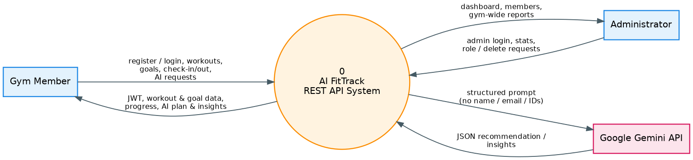
Level 1 DFD – Processes and Data Stores
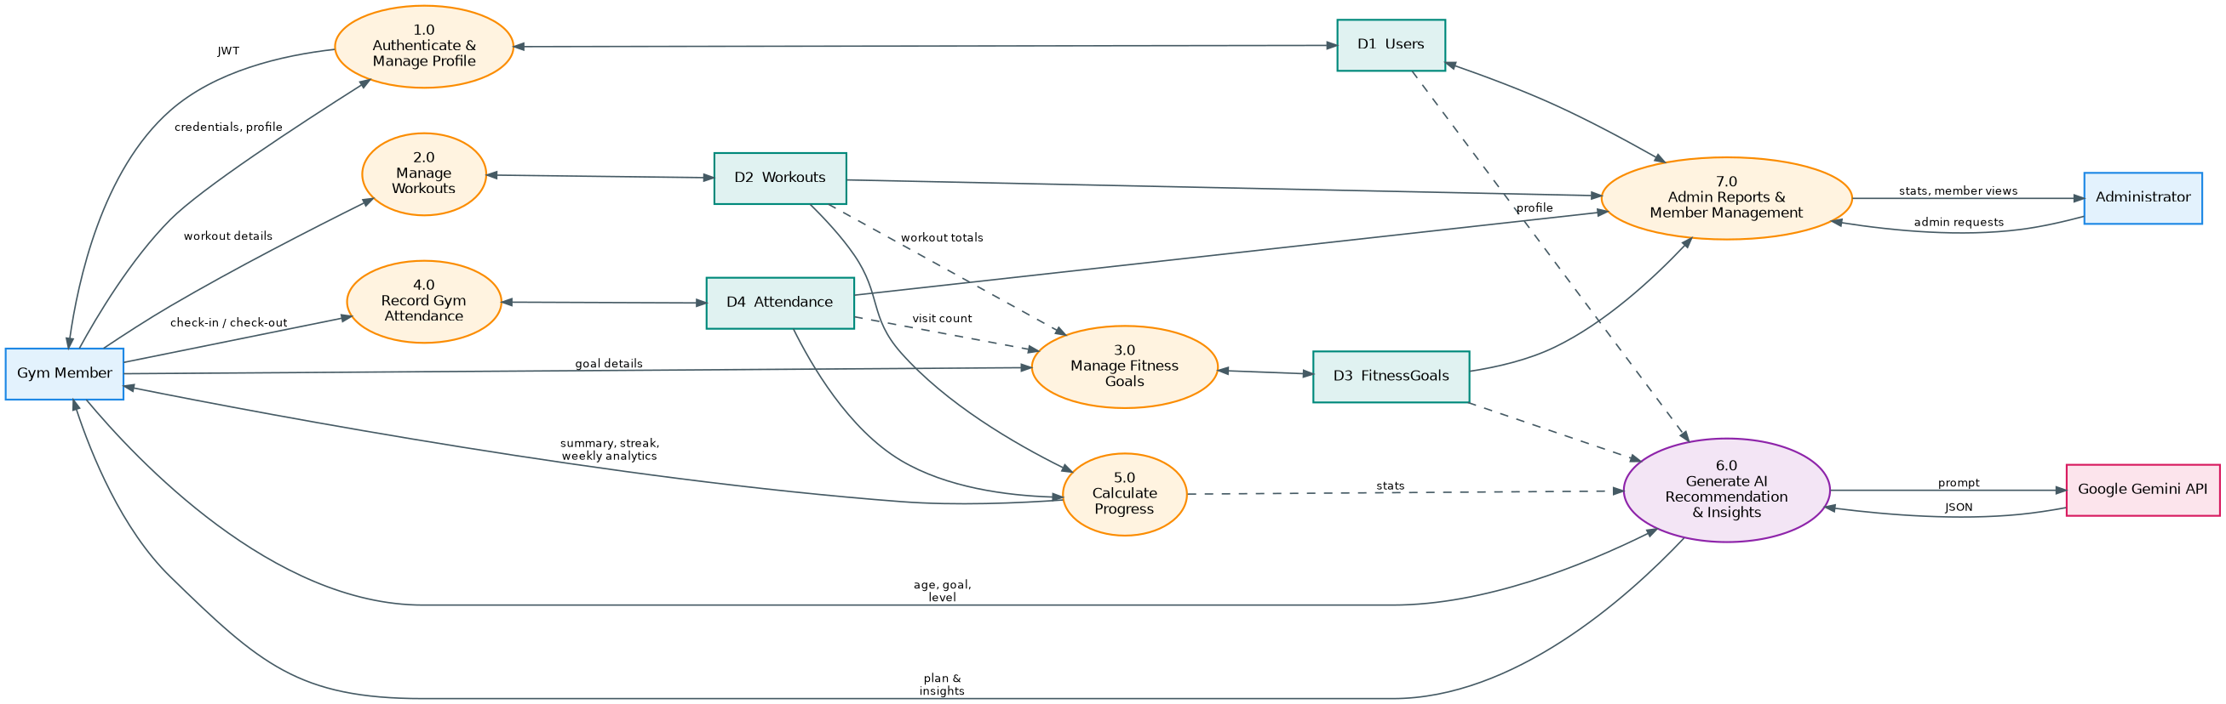
Data stores (MongoDB collections): D1 Users, D2 Workouts, D3 FitnessGoals, D4 Attendance. External entities: Gym Member, Administrator, Google Gemini API. Fitness profile attributes needed for recommendation (age, fitness goal, experience level, height and weight), active goal data, recent workout data and calculated progress flow to Gemini; name, email and database IDs are not sent.

User Stories
Use the below template to list all the user stories for the product.
User Type | Functional Requirement (Epic) | User Story Number | User Story / Task | Acceptance criteria | Priority | Release
Member | Registration | USN-1 | As a member, I can register by entering my name, email and password. | Account is created (201) and a JWT is returned; role is always "user"; duplicate email is rejected (409) | High | Sprint-1
 | Login | USN-2 | As a member, I can log in with my email and password and receive a token. | Valid credentials return a JWT (HS256); wrong credentials return 401 | High | Sprint-1
 | Authentication & Security | USN-3 | As a member, my protected requests are authenticated with a Bearer token so only I can see my data. | Missing / invalid / expired token returns 401; admin routes return 403 for non-admins | High | Sprint-1
 | Profile | USN-4 | As a member, I can view and update my fitness profile (age, height, weight, experience level, fitness goal). | Profile is saved and returned without password; invalid values return 400 | High | Sprint-1
 | Workout Management | USN-5 | As a member, I can add a workout with name, category, duration, calories and date. | Workout is created (201) and linked to my account; invalid data returns 400 | High | Sprint-1
 |  | USN-6 | As a member, I can view my own workouts, newest first, with pagination. | Only my workouts are listed with page / limit details | High | Sprint-1
Developer / API Tester | Project Setup | USN-7 | As a developer, I can start the server, check /api/health and receive consistent JSON success and error responses. | Health returns server / database / Gemini status; every error follows the { success, message } format | High | Sprint-1
Member | User Interface | USN-8 | As a member, I can use React pages for register, login and the dashboard. | After login I reach the dashboard showing my totals and recent workouts | Medium | Sprint-1
 | Workout Management | USN-9 | As a member, I can edit and delete my own workouts. | Update / delete works for my workouts; another member's workout returns 403; unknown id returns 404 | High | Sprint-2
 |  | USN-10 | As a member, I can search my workouts by text, name, category or date. | Matching workouts of mine are returned; search text is safely escaped | Medium | Sprint-2
 | Fitness Goals | USN-11 | As a member, I can create a fitness goal with a metric, target value and target date. | Goal is created (201); progress and status are calculated by the server; invalid dates / targets return 400 | High | Sprint-2
 |  | USN-12 | As a member, I can view, update and delete my goals and see progress update automatically. | Goal progress (0–100) follows logged workouts / visits; only active or cancelled can be set manually | High | Sprint-2
 | Gym Attendance | USN-13 | As a member, I can check in when I arrive at the gym. | Check-in creates an open visit (201); a second check-in returns 409 | High | Sprint-2
 |  | USN-14 | As a member, I can check out when I leave the gym. | Visit is closed and duration in minutes is stored; check-out without a visit returns 409 | High | Sprint-2
 |  | USN-15 | As a member, I can view my attendance history filtered by date. | My visits are listed newest first with from / to filters and any open visit | Medium | Sprint-2
 | User Interface | USN-16 | As a member, I can manage workouts, goals and attendance from React pages. | Pages for workout log, add / edit workout, goals and attendance work against the API | Medium | Sprint-2
 | Progress Analytics | USN-17 | As a member, I can see my progress summary: totals, category split, streaks and consistency. | Summary is calculated live from my workouts and visits | High | Sprint-3
 |  | USN-18 | As a member, I can see week-by-week progress for the last N weeks. | Weekly buckets (Monday–Sunday) are returned oldest first, including empty weeks | Medium | Sprint-3
 | AI Recommendation | USN-19 | As a member, I can request an AI workout recommendation based on my profile, goals and recent workouts. | Structured plan with weekly schedule, tips, safety advice and a non-medical disclaimer; missing profile fields return 400 | High | Sprint-3
 | AI Fitness Insights | USN-20 | As a member, I can get AI fitness insights from my own workout statistics. | Performance analysis, 3–5 suggestions and motivation are returned; with no workouts, insights is null and no AI call is made | High | Sprint-3
 | AI Reliability | USN-21 | As a member, I get a clear message if the AI service is busy, slow or not configured. | Timeouts and temporary failures are retried (max 3); errors return 429 / 500 / 502 / 503 / 504 without leaking details | High | Sprint-3
 | User Interface | USN-22 | As a member, I can view progress, AI recommendation and AI insights pages in the web app. | Pages show the API data and errors are shown as banners | Medium | Sprint-3
Administrator | Admin Dashboard | USN-23 | As an administrator, I can view system-wide statistics on a dashboard. | Users, workouts, goals, progress days and attendance totals are shown; non-admin gets 403 | High | Sprint-4
 | Member Management | USN-24 | As an administrator, I can see a members overview and open the details of any member. | Each member shows workouts, goals, attendance, last activity and Active / Inactive status | High | Sprint-4
 |  | USN-25 | As an administrator, I can view gym-wide workouts, goals, progress and attendance, filtered by member. | Lists are searchable and filterable and agree with the member's own pages | Medium | Sprint-4
 |  | USN-26 | As an administrator, I can change a user's role or delete a user. | Role / delete works for other users; own role / account cannot be changed; delete removes the user's data | Medium | Sprint-4
Developer / API Tester | Testing | USN-27 | As a tester, I can run automated tests and Thunder Client test cases for the whole API. | npm test and npm run test:api pass; manual test sequence is documented | High | Sprint-4
Member |  | USN-28 | As a member / administrator, I can take part in user acceptance testing and report bugs. | UAT cases are executed, bugs are logged with severity and status | High | Sprint-4
Developer / API Tester | Documentation | USN-29 | As a stakeholder, I can read the technical documentation and access the supplied project files. | Technical documentation is included in the supplied project files; no demo-video URL or source-code URL is included in the supplied files. | Medium | Sprint-4

